Enter the time here or press the symbol to select it from the options.

Navigate between pages here

Access the train schedules via these links.

Choose a day from the dropdown box or begin typing it in and select it.

Select stations here by typing the first letters and choosing the station or by just selecting it from the dropdown box.

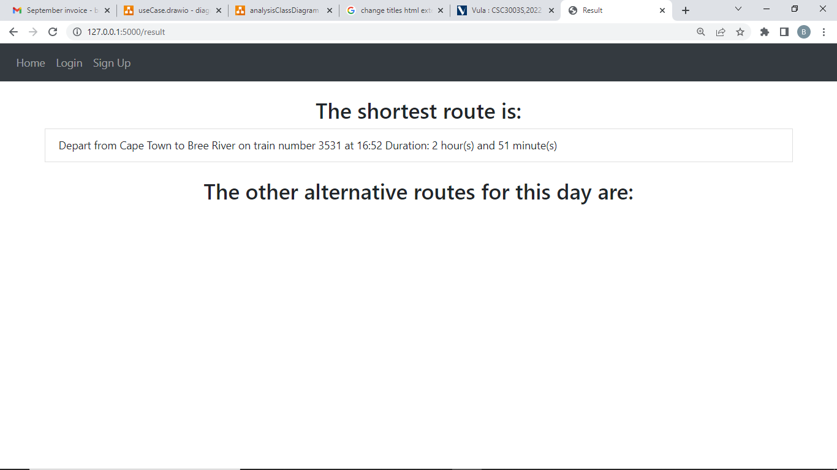

Any additional routes will be displayed here.

The fastest route is displayed here.

For logged in users, search history is displayed here.